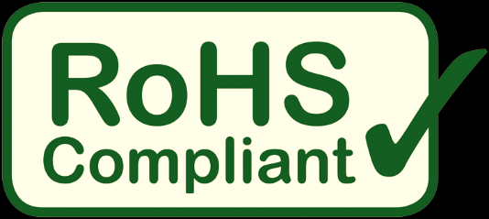
Much of RoHS3 (EU Directive 2015/863) is not applicable to many of HiRel Connectors’ parts because the directive largely regulates consumer products. In addition to exemptions listed in annexes III and IV, products meant for military purposes are also exempt.
Lead – Some parts use lead solder, and are not RoHS3 compliant.
Cadmium – A few of HiRel Connectors’ parts require Cadmium plating, and are not RoHS2 compliant. Cadmium (Cd), as supplied by HiRel Connectors, does not require additional handling precautions.
For more detailed information regarding RoHS3 compliance, visit the EU RoHS website, or contact us at info@hirelco.net.

