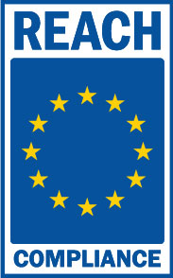
REACH was adopted by the European Union on June 1st, 2007. The regulation aims to protect human health and the environment by managing the use of chemicals in industrial and consumer processes. Safe use of REACH regulated chemicals must be effectively communicated if marketed or supplied in the European Union.
Numerous connectors and connector accessories supplied by HiRel Connectors have a customer mandated Cadmium (Cd) plated finish, which does not require additional handling precautions. Cadmium (CAS No 7440-43-9) was included in the Candidate List of Substances of Very High Concern for authorization on 20 June 2013 under decision number ED/69/2013.
The human body or the environment can be put in to danger whenever Cadmium is manufactured, or used in the formulation of mixtures and in processing aids. For more detailed information regarding the dangers and safe use of Cadmium, refer to the EU REACH website.
Cadmium should be disposed of in accordance with all applicable governmental regulations relevant to the geographical location.

